Sample Queries Output

SELECT label, COUNT(*) AS cnt
FROM events_fact
GROUP BY label;

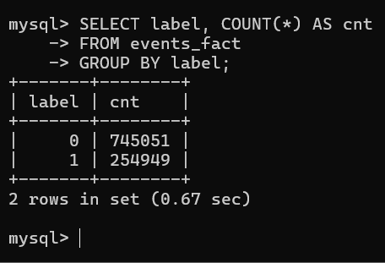

SELECT
AVG(feature1) AS avg_f1,
MIN(feature1) AS min_f1,
MAX(feature1) AS max_f1
FROM events_fact;

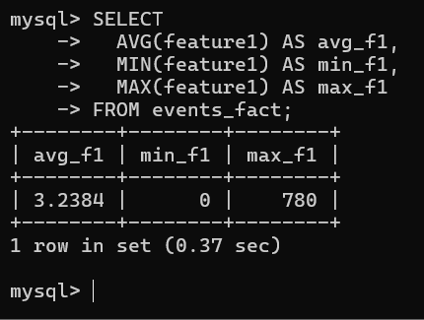

SELECT
PARTITION_NAME,
TABLE_ROWS
FROM information_schema.PARTITIONS
WHERE TABLE_SCHEMA = 'ad_analytics'
AND TABLE_NAME = 'events_fact';

